URL: https://adityabirlahospital.com/doctors/vascular-surgeon-in-pune
Home / Doctors / Vascular Surgeon
Best Vascular Surgeons in Pune
When vascular health requires attention, choosing experienced specialists is crucial. At our hospital, you’ll find leading vascular surgeons in Pune who provide advanced care for conditions affecting arteries, veins, and the lymphatic system.
Our Team of the Top Dentists in Pune
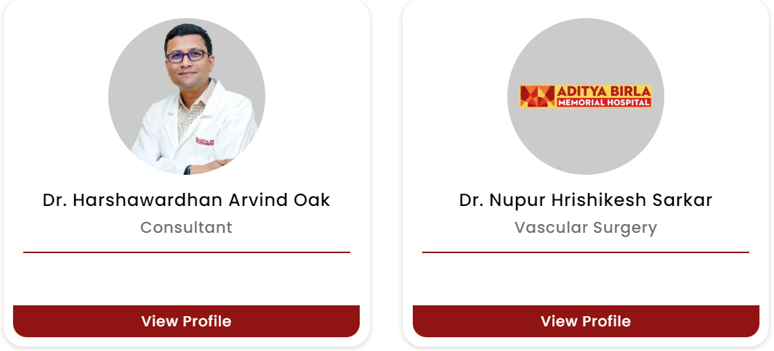
Our vascular care team is renowned for its expertise in treating a wide range of conditions. Whether you need treatment for varicose veins or a life-saving intervention, our vascular specialists in Pune deliver patient-focused care with cutting-edge technology, ensuring some of the best outcomes.
What Our Vascular Surgeons Specialise In:
How to Find the Top Vascular Surgeons Near Me in Pune?
If you’re searching for the best vascular surgeon in Pune, our team stands out for its blend of expertise and patient care. Each treatment is tailored to individual needs, ensuring optimal results every time.
Nearby Locations:
Hinjewadi, Wakad, Baner, Aundh, Pimple Saudagar, Bhosari, Ravet, Chinchwad Gaon, Tathawade and Nigdi.


